DATE: 21.08.2025
EXPERIMENT – 15 Create a Cloning of a VM and Test it by loading the Previous Version/Cloned VM using vmware workstation
Aim:
To create a clone of a virtual machine and test it by loading the cloned VM using VMware Workstation.
Procedure:
- Open VMware Workstation and select the virtual machine to be cloned.
- Ensure the VM is powered off before cloning.
- Go to VM → Manage → Clone.
- The Clone Wizard will appear → Click Next.
- Select Clone from an existing snapshot or current state.
- Choose Full Clone (creates a complete independent copy) or Linked Clone (shares virtual disks with parent).
- Provide a name and location for the cloned VM.
- Click Finish → VMware will create the cloned VM.
- Once created, power on the cloned VM from the VMware Workstation library.
- Test the cloned VM to verify it loads properly and works independently of the original VM.
Output:
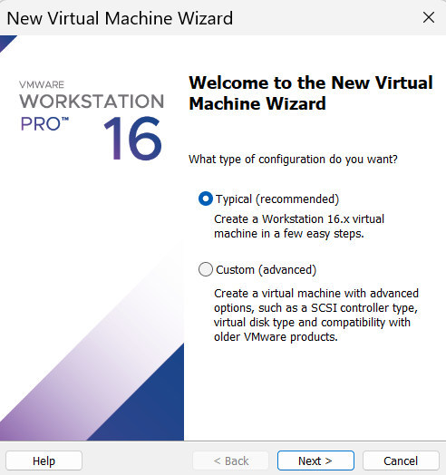
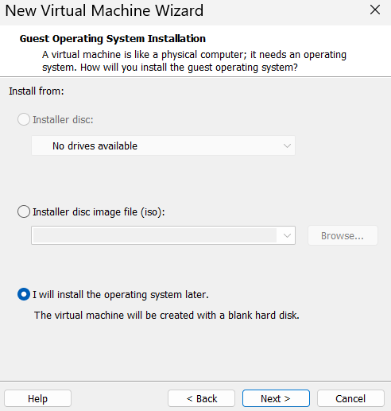

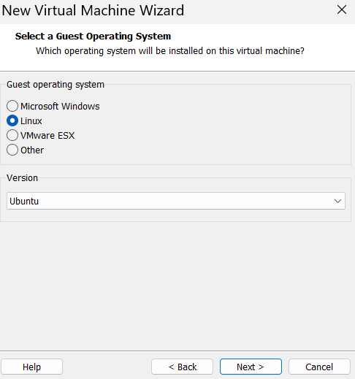

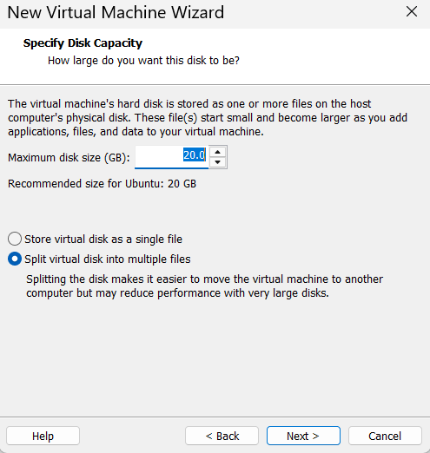

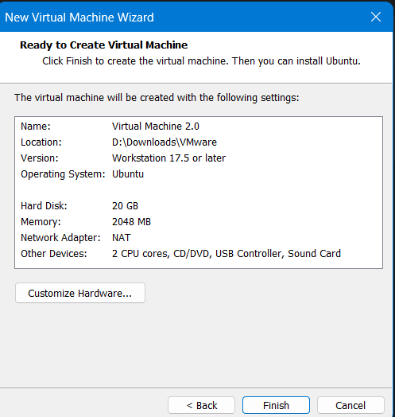

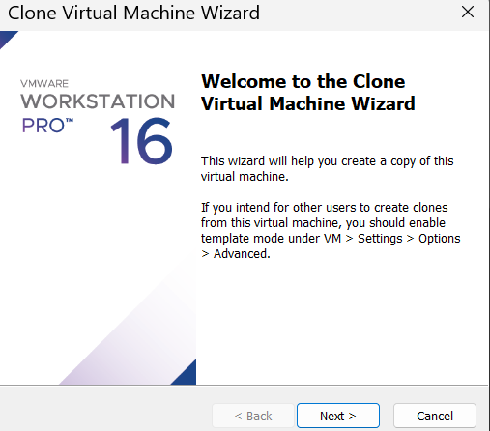

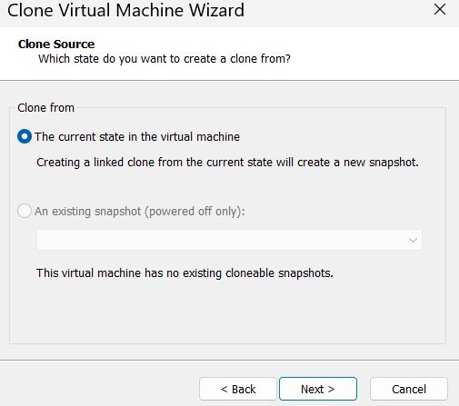
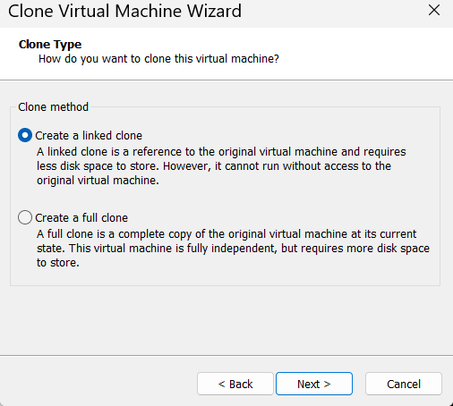

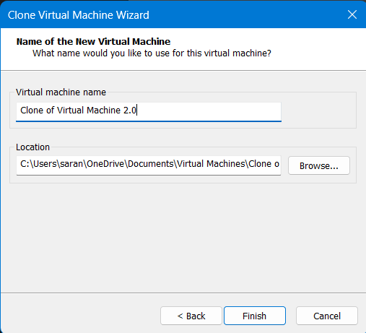
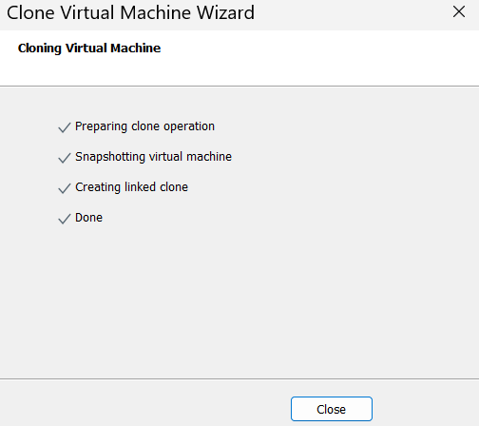
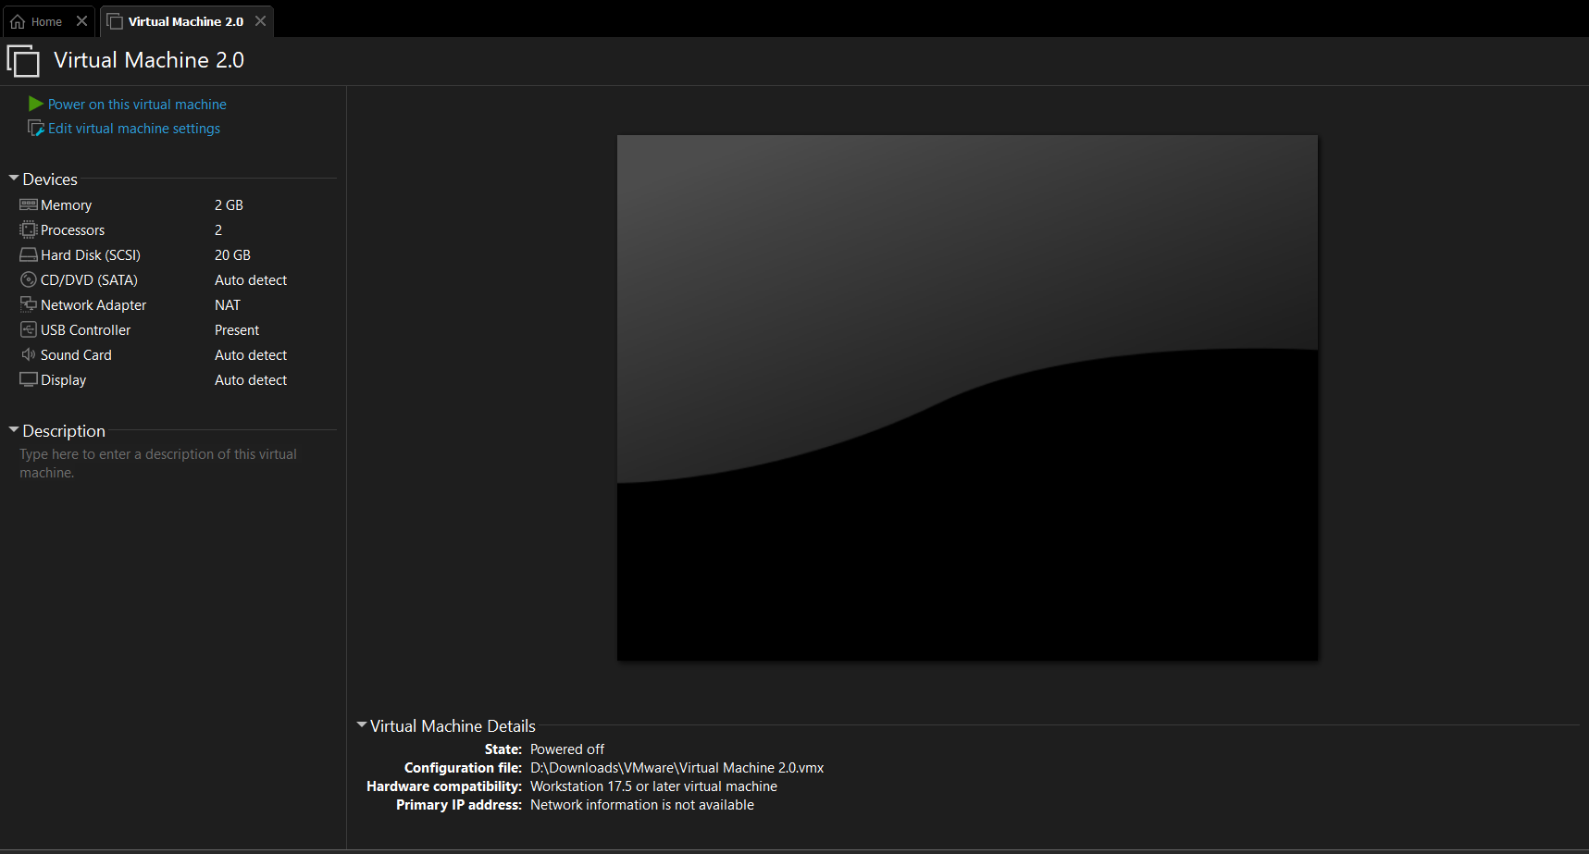
Result:
A clone of the VM was successfully created and tested. The cloned VM loaded correctly and functioned independently from the original VM, demonstrating the cloning feature of VMware Workstation.

